**Sprint 1 Plan**

**Product Name:** SummarAIze

**Sprint Completion Date:** April 21, 2025

**Revision Number:** V1.1

**Revision Date:** April 10th, 2025

**Scrum Meeting Times:** M - 12:00-2pm, W - 12:00-2pm, F - 9:30am - 10:30am (Meeting with TA)

**High-Level Goal:** Complete the overall basic set-up for the project, finalize main goals, and delegate tasks.

**Task Listing:**

* {1} Summary and Web Application
* **As a student, I need to upload a research paper PDF through an accessible website and get an accurate summary of the paper so I can understand the main points without reading the entire paper. [8]**
  + Task 1: Get the Open AI API (1 hour)
  + Task 2: Implement GPT Wrapper (2 hours)
  + Task 3: Set up Github (30 min)
  + Task 4: Create a spreadsheet with API pricing (to split costs) (30 min)
  + Task 5: Create the Wireframe (1 hr)
  + Task 6: Code a basic UI with PDF upload (2 hours)
  + Task 7: Create a React web application (30 min)
  + Task 8: Create a place for backend to go (30 min)
  + Task 9: Adding title and basic CSS formatting (1 hr)
  + Task 10: Connect Firebase to backend (30 min)
  + Task 11: Add authentication to frontend (30 min)
  + Task 12: Connect frontend to backend (1 hr)
  + Task 13: Create docker containerization (1 hr)
* {2} Summary Complexity
* **As a user, I want to indicate that I have no background knowledge on the research topic and receive a detailed literature review so that I can learn more about the subject. [5]**
  + Task 1: Add toggle for background knowledge or not; Advanced/Basic (30 min)
  + Task 2: Generate the simplified explanations for Basic user using Open AI API (2 hours)

Team Roles:

Koena: Project Owner, Developer

Ashton: Scrum Master, Developer

Poojitha: Developer

Amisha: Developer

Nathan: Developer

**Scrum Board:**

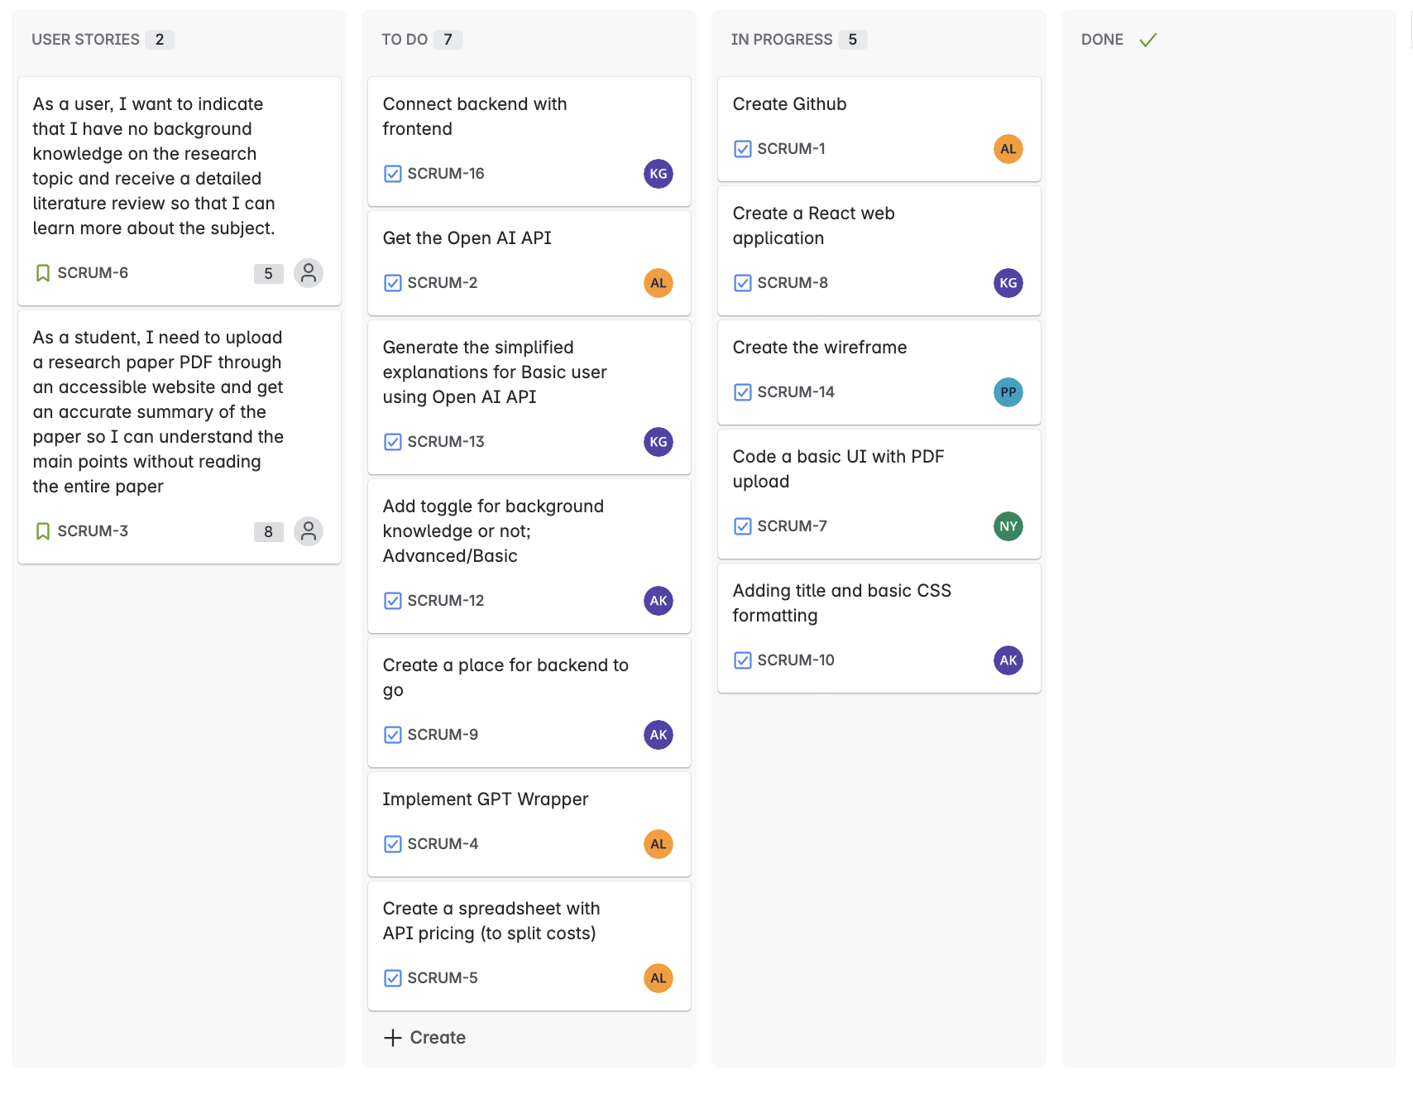

**Burn-up chart:**

